233/1
CHEMISTRY
PAPER 1
JULY / AUGUST 2011
2 HOURS

Kenya Certificate of Secondary Education2011
CHEMISTRY
PAPER 1
2 HOURS.
- An isotope of element E has 34 neutrons and its mass number is 64. E forms a cation with 28 electrons. Write the formula of the cation indicating the mass and atomic number. ( 1 mark )
- When 8.53g of Sodium Nitrate were heated in an open test-tube, the mass of oxygen produced was 0.83g. Given the reaction as
2NaNO_{3(s)} 2NaNO_{2(s)} + O_{2(g)}
Calculate the percentage of Sodium Nitrate that was converted to Sodium Nitrite.
(Na = 23.0, N = 14.0, O = 16.0) ( 3 marks )
- Classify the following processes as either chemical or physical. ( 3 marks )
Process | Type of change
(a) Heating copper (II) sulphate crystals
(b) Obtaining kerosene from crude oil
(c ) Souring of milk
- starting with red roses, describe how;
- A solution containing the red pigment may be prepared. ( 2 marks )
- The solution can be shown to be an indicator. ( 2 marks )
- When a hydrated sample of calcium sulphate CaSO₄.Xh₂O was heated until all the water was lost, the following data was recorded.
  - Mass of crucible = 30.296g
  - Mass of crucible + hydrated = 33.111g
  - Mass of crucible + anhydrous salt = 32.781g
(Ca = 40, S = 32, O = 16, H = 1)
Determine the value of X and hence write the formula of the hydrated salt. ( 3 marks )
- Zinc reacts with both concentrated and dilute sulphuric acid. Write an equation for the two reactions. ( 2 marks )
- (a) State Graham’s law of diffusion. ( 1 mark )
(b) The molar masses of gases W and X are 216.0 and 44.0 respectively. If the rate of diffusion of W through a porous material is 12cm³/s. Calculate the rate of diffusion of X through the same material. ( 3 marks )
- Complete the following table by filling in the missing test and observation. ( 3 marks )
No | Gas | Test | Observation
I | Chlorine | Put a moist red litmus into a gas jar
II | Sulphur (II) Oxide |  | Solution turns green
III | Butene | Add a drop of bromine
- Carbon (IV) Oxide reacts with hydrogen to form methanol and oxygen under certain condition.
The reaction is represented by the equation below.
2CO_{2 (g)} + 4H_{2(g)} 2CH₃OH + O₂; ΔH = +1422
What would be the effect on the yield of methanol if the temperature of the reaction of the mixture is increased? Explain. ( 2 marks )
- (a) Thorium – 232 delays the emission of beta and alpha particles. Part of the decay series is shown below. Indicate the atomic mass and atomic number of E and D.
₂₃₂
Th β E α D ( 2 marks )
⁹⁰
(b) 1g of radio active molebdenum decays to ¹/₈ g in 200hours. What is the half-like of molebdenum. ( 2 marks )
- In a sample of element X, the percentage abundance of ₆₉ is 60% and ₇₁ is 40%.
X X
³¹ ³¹
(a) Calculate the R.A.M of X. ( 2 marks )
(b) Explain why the two isotopes have the same chemical properties? ( 1 marks )
- In the manufacture of blue band margarine, nickel is used as catalyst. An addition reaction involving vegetables, oils and hydrogen takes place.
- What is an addition reaction? ( 1 mark )
- What type of bond must be present in the vegetables oils for this reaction to occur? ( 1 mark )
- Use the half cell reaction and standard electrode potentials given below to show that chlorine can displace iodine from a solution containing iodine ions. ( 2 marks )
Half cell reactions
Cl_{2(g)} + 2e⁻ 2Cl⁻_{(aq)} + 1.36V
I_{2(g)} + 2e⁻ 2I + 0.54 V
- During the extraction of aluminium from its ores, the ore is first purified to obtain alumina. The chart below shows the stages in the extraction of aluminium from alumina.
Molten
Aluminium
Alumina Step I Liquid Step 2
C₁ Alumina Process D₁
Heat Oxygen
  - Name
  - Substance C₁ ( 1 mark )
  - Process D₁ ( 1 mark )
- Give two reasons why aluminium is used extensively in making of cooking pan. ( 1 mark )
- Solid A dissolves in water forming a colourless solution. The solution was divided into two portions.
To the second portion ammonia solution was added until excess. In both a white precipitate was formed which dissolved in excess sodium hydroxide solution forming a colourless solution.
(a) Write an equation between solution A and ammonia solution. ( 2 marks )
(b) Name the complex ion formed when solution A reacts with
(i) Ammonia solution in excess. ( 1 mark )
(ii) Sodium hydroxide solution in excess. ( 1 mark )
- Use the bond energies given below to determine whether the reaction given below is exothermic or endothermic. ( 3 marks )
C – C = 346 kJmol⁻
C – H = 413 kJmol⁻
C = C = 610 kJmol⁻
H – H = 435 kJmol⁻

H H H H

C C + H_{2(g)} H C C H

H H_{(g)} H H_{(g)}
- Study the diagram below and answer the questions that follow.

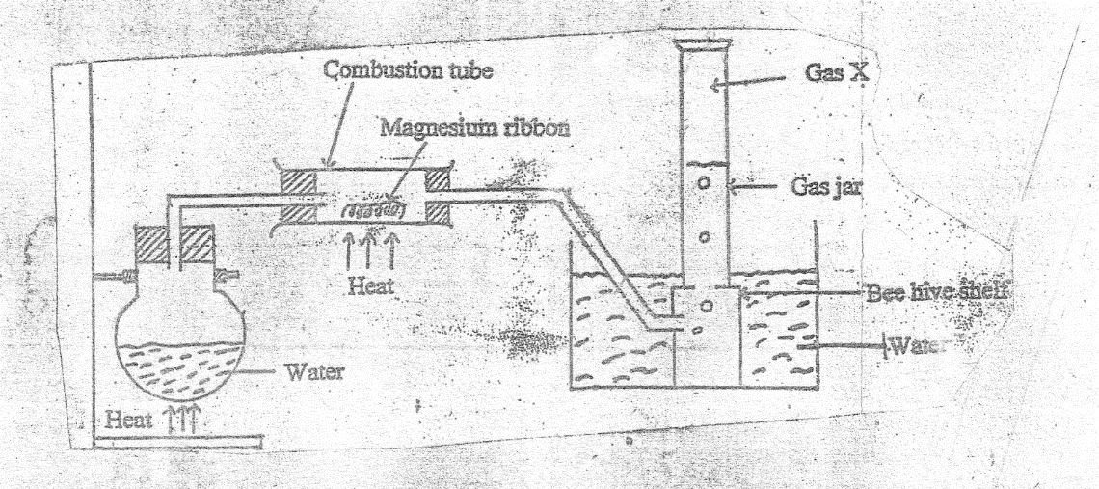

(a) Write a chemical equation for the reaction taking place in the combustion tube. ( 1 mark )
(b) Give two reasons why it is necessary to heat the water first before heating magnesium ribbon. ( 2 marks )
- Study the flow chart below and answer the questions that follow.

N₂
Step I NH₃ Step II Colourless gas B
Catalyst A Catalyst C
H₂ O₂ O₂ H₂O Step III

Nitric Acid
(a) Name catalyst A ( 1 mark )
(b) Name gas B ( 1 mark )
(c ) Apart from catalyst A, what other condition facilitates reaction in step II. ( 1 mark )
(d) Write an equation for the reaction in step III. ( 1 mark )
- State two differences between compounds and mixture. ( 2 marks )
- A student wanted to determine the solubility of potassium nitrate. He obtained the following results.
Mass of evaporating dish = 14.32g
Mass of evaporating dish + solution = 35.70g
Mass of evaporating dish + salt = 18.60g
Calculate the solubility of potassium nitrate from the above results. ( 3 marks )
- Why is solid carbon (IV) Oxide dry ice preferred in cool boxes to normal ice that is solid water. ( 2 marks )
- Explain how electro-plating prevents rusting. ( 2 marks )
- The volume of a sample of nitrogen at temperature of 291k and 1.0 x 10⁵ pascals is 3.5 x 10⁻² m³.
Calculate the temperature at which the volume of the gas would be 2.8 x 10⁻²m³ at 1.0 x 10⁵ pascals. (3 marks )
- Butane is a hydrogen which shows only branching isomerism. Draw and name two possible structures of the isomers of butane. ( 3 marks )
- Name two methods that can be used to remove permanent hardness from water. ( 2 marks )
- Use the information given below to answer the questions that follow.
Solution | pH
A | 1.5
B | 7.0
C | 9.8

Which of the above solutions will not affect the colour of red litmus paper. Explain. ( 2 marks )
- The diagram below shows the combustion of propane gas.
Gas P to suction pum

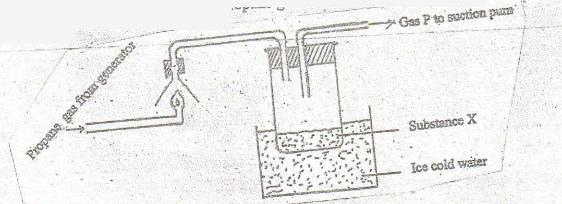

(a) Identify substance X _____________________________________________ ( 1 mark )
(b) Write the equation for the complete combustion of propane gas. ( 1 mark )
(c) What is the purpose of ice cold water in the experiment? ( 1 mark )
(d) The pH of substance X was found to be less than 7. Explain this observation. ( 1 mark )
- Study the scheme below and answer the questions that follow.

Yellow residue

Solid Q Heat
white
Brown gas + oxygen
(a) Name
(i) Solid Q ( 1 mark )
(ii) The yellow residue ( 1 mark )
(b) Write an equation for the decomposition of solid Q. ( 1 mark )
- Draw the structure and name the alkanol with six carbon atoms. ( 1 mark )

