BIOLOGY 231/1
QUESTIONS
SECTION A (20 MKS)
Answer all questions in this section in spaces provided

- Motor vehicles move, use energy and produce carbon dioxide and water. Similar characteristics occur in living organisms yet motor vehicles are not classified as living ( 3 mks)
- Name the organelle that performs each of the following functions in a cell
( 2 mks)
Proteins synthesis
Transport of cell secretions
- State two ways in which some fungi are harmful to man ( 2 mks)
- Explain what would happen to red blood cells if they are placed in a concentrated salt solution ( 2 mks)
- State the role of light photosynthesis ( 2 mks)
- The diagram below represents a fern
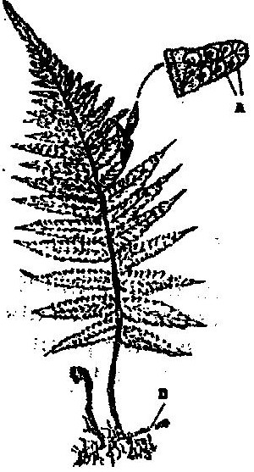

Name
  - The parts labeled A and B ( 2 mks)
  - The division to which the plant belongs ( 1 mk)

- Complete the table below on mineral nutrition in plants ( 3 mks)

Mineral element | Function | Deficiency symptoms
 | Synthesis of proteins and protoplasm | Stunted growth and yellowing of leaves
Calcium
 | Forms part of chlorophyll | Yellowing of leaves

- Explain why Larmacks theory of evolution is not accepted by biologists today ( 2 mks)

- name a is disorder of human blood that is caused by mutation ( 1 mk)

SECTION B (40 MARKS)
- An experiment was carried out to investigate the rate of reaction shown below
Sucrose →Fructose + Glucose
For the products fructose and glucose to be formed, it was found that substance K was to be added and the temperature maintained at 37⁰C. When another substance L was added, the reaction slowed down and eventually stopped.
(a) Suggest the identify of substances K and L ( 2 mks)
(b) Other than temperature state three ways by which the rate
of reaction could be increased ( 3 mks)
(c) Explain how substance L slowed down the reaction ( 2 mks)

- The diagram below represents a transverse section of a young stem
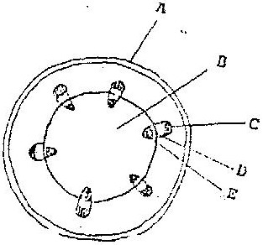

  - Name the parts labeled A and B ( 2 mks)
  - State the functions of the parts labeled C, D and E ( 4 mks)
  - List three differences between the section shown above and one that would be obtained from the root of the same plant ( 3 mks)

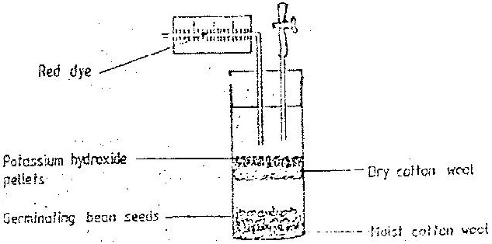
- The diagram below shows an experimental soil up to investigate an aspect of germination

(a) Why are sodium hydroxide pellets used in this experiment? (1 mk)
(b) Why is moist cotton wool used in this experiment? (1 mk)
(c) (i) By means of an arrow, indicate on the diagram the direction in which red
dye would move during the experiment. (1 mk)
(ii) Give reasons for your answer in (c) (i) above (3 mks)

- The chart below shows a feeding relationship in a certain ecosystem
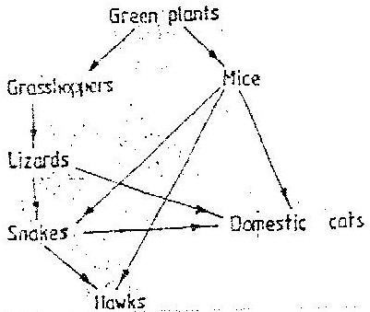

  - Construct two food chains ending with a tertiary consumer in each case ( 2 mks)

  - Which organism has the largest variety of predators in the food web?
(1 mk)
  - Name secondary consumers in food web (2 mks)

  - Suggest three ways in which the ecosystem would be affected in there was a prolonged drought.

- The diagram below represents growing seedlings which were subjected to unilateral light at the beginning of an experiment
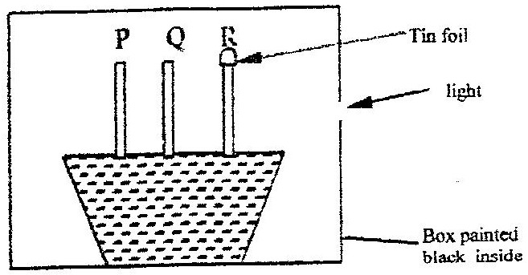

(a) (i) State the results of P,Q and R after 5 days? ( 5 mks)
(ii) Account for your answer in (a) (i) above ( 3 mks)

(b) If the tin foil were removed from the tip of the seedling R, what results would be observed after 2 days? (1 mk)

- State the expected results after 3 days if the box were removed
( 1 mk)

SECTION C (40 Mks)
Answer questions 15 (compulsory) in the spaces provided and one question from this section in the spaces provided after question 17

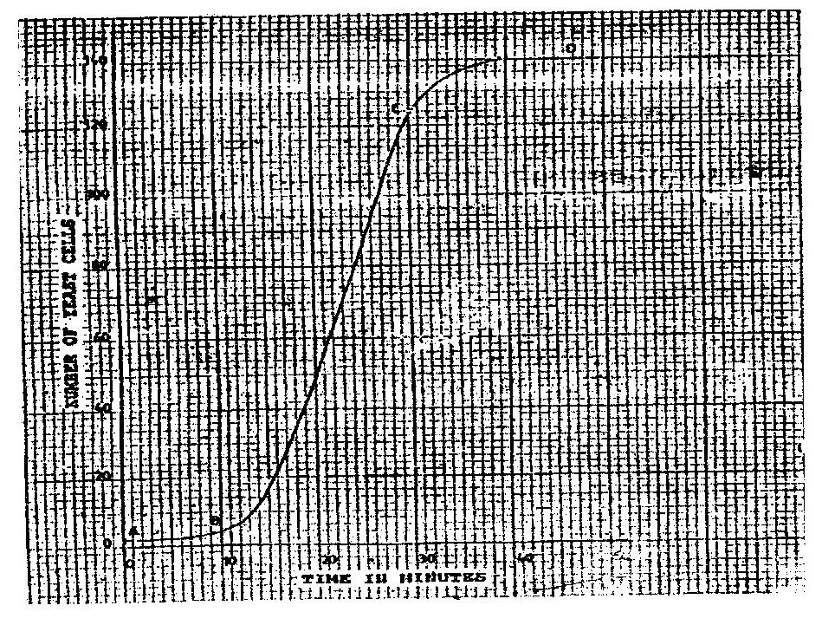
- The graph below represents the increase in the number of yeast cells over a period of 48 minute

(a) Name the type of curve shown ( 1 mk)
(b) Determine the number of yeast cells after 26 minutes ( 1 mk)
(c) Work out the rate of cell division between 24 and 28 minutes
( 2 mks)
(d) After how long was the population of yeast cells 128? 1 mk)
(e) Name the phase of the curve labeled
(i) A to B
(ii) B to C
(f) Give reasons for the shape of the graph between points C and D
( 3 mks)
- State five factors, which would cause human population
growth to assume the shape of the graph curve between points B and C ( 5 mks)
- Describe how the quadrat method can be used to estimate the
population of various species of plants in a given habitat ( 5 mks)

- (a) Describe how insect pollinated flowers are adapted to pollination
(b) Describe the role or each of the following hormones in the human menstrual cycle
(i) Oestrogen
(ii) Progesterone
(iii) Luteinising hormone ( 9 mks)
- Describe how excretion takes place in
(i) Mammalian Kidneys
(ii) Green plants ( 5 mks)

BIOLOGY PAPER 231/2 K.C.S.E 1995
PRACTICAL MARKING SCHEME

1. Confidential requirement: Specimen K – 5 Rastrineobolla argenti
(Omena in Luo)

You are provided with a specimen labelled K. With the help of a hand
lens examine the specimen.
a) (i) State the phylum to which the specimen belongs chordata;
(ii) Using the observable features only, name the class to which
the specimen belongs.
Pisces.
(iii) Give your answer in (a) (ii) above
Lateral line / operculum / gill cover / gills, fins
Acc. fish, osteichythes / bonny fish etc
b) Using the observable features, only state how the animal
is adapted to living in its habitat.
-Streamlined body for easy movement / minimize friction (owwte)
-Presence of fins for swimming / balance
-presence of gills for breathing in water/gaseous
Exchange / operculum / gills cover to allow water of pass out.
-Presence of lateral line helps vibration / movements in water
Waves / disturbance in water.
c) Cut three of specimen K into tiny pieces. Place the pieces into a boiling tube. Add 5m if water. Boil for five minutes. Decant the extract into a clean test tube.
Using the reagents provided, identity the food substances in the extract. Record the food substances being tested for observations and conclusions in the table below.

Food substance | procedure | observations | Conclusion
Protein | To the extract add dilute Na0H solution and 1% copper sulphate; | Violet/purple colour appears | Protein present
Reducing sugar | To the extract add Benedict’s solution boil / warm | No colour change | Reducing sugar absent.

