Pre-Mock Examinations 2017

Chemistry Paper 2

80 marks 2 Hours

Name ……………………………………………………… date …………………….

- The grid below represents part of the periodic table. Study it and answer the questions that follow. The letters are not the actual symbols of the elements.
A |  |  |  |  | B |  | C
 | D |  |  | E |  | F | G
H

- Select the most reactive metal. Explain. (2 marks)

- Select an element that can form an ion with a charge of 3⁻. (1 mark)

- Select an alkaline earth metal. (1 mark)

- Which group 1 element has the highest first ionization energy? Explain. (2 marks)

- Element A combines with chlorine to form a chloride of A. State the most likely pH value of solution of a chloride of A. Explain. (2 marks)

(b) (i) Explain why molten calcium chloride and magnesium chloride conduct electricity while carbon tetrachloride and silicon tetrachloride do not. (2 marks)

(ii) Under the same conditions, gaseous neon was found to diffuse faster than gaseous fluorine.
Explain this observation. (F = 19.0; Ne = 20.0) (2 marks)

- (a)The scheme below shows some of the reactions of solution D. Study it and answer the questions that follow.
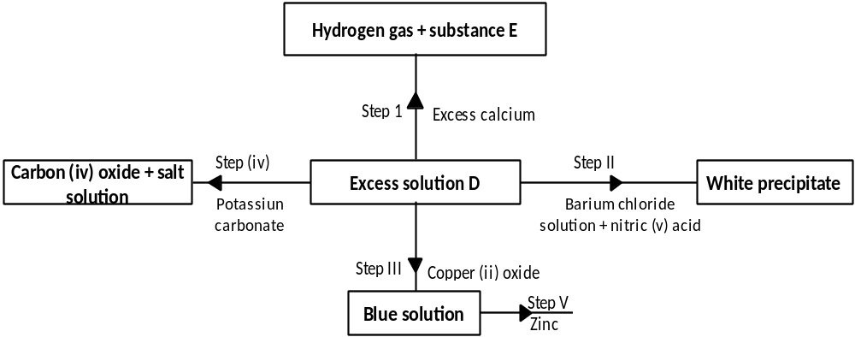

(i) Give a possible cation present in solution D. (1 mark)

(ii) Write an ionic equation for the reaction in Step II. (1 mark)

(iii) What observations would be made in Step V? Give a reason. (2 marks)

(iv) Explain why the total volume of hydrogen gas produced in step 1 was found to be very low
although calcium and solution D were in excess. (2 marks)

(v) State one use of substance E. (1 mark)

(b) (i) State a property of anhydrous calcium chloride which makes it suitable for use as a drying agent for
chlorine gas. (1 mark)

(ii) Name another substance that can be used to dry chlorine gas. (1 mark)

- The diagram below represents a set up that was used to obtain dry nitrogen from air.
Study it and answer the questions that follow.

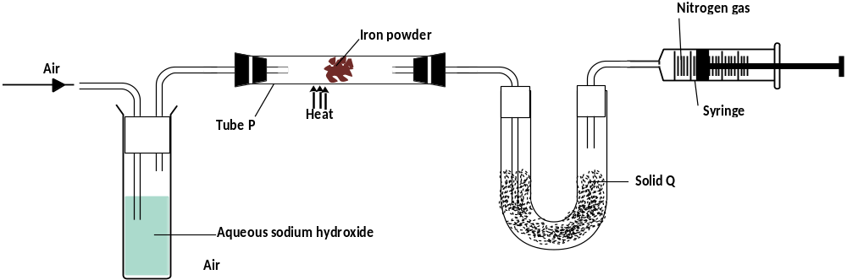

- Name solid Q (1 mark)

- What is the purpose of sodium hydroxide? (1 mark)

- Write an equation for the reaction which took place in tube P. (1 mark)

- Give the name of one impurity present in the nitrogen gas obtained.(1 mark)

- Give a reason why liquid nitrogen is used for storage of semen for artificial insemination. (1 mark)

(b) The set up below was used to prepare nitric (V) acid
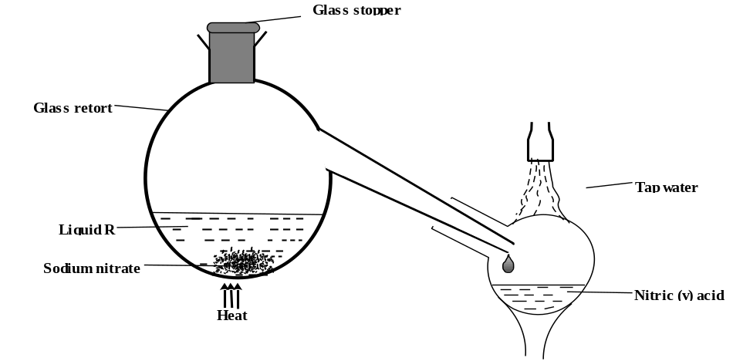

- Give the name of liquid R. (1 mark)

- Write an equation for the reaction which took place in the glass retort. (1 mark)
- Explain the following

I. Nitric acid is stored in dark bottles. (1 mark)

II. The reaction between copper metal with 50% nitric acid (one volume of acid added to an equal volume of water) in an open test tube gives brown fumes. (2 marks)

- The diagram below shows some processes that take place during the industrial manufacture of sulphuric acid.
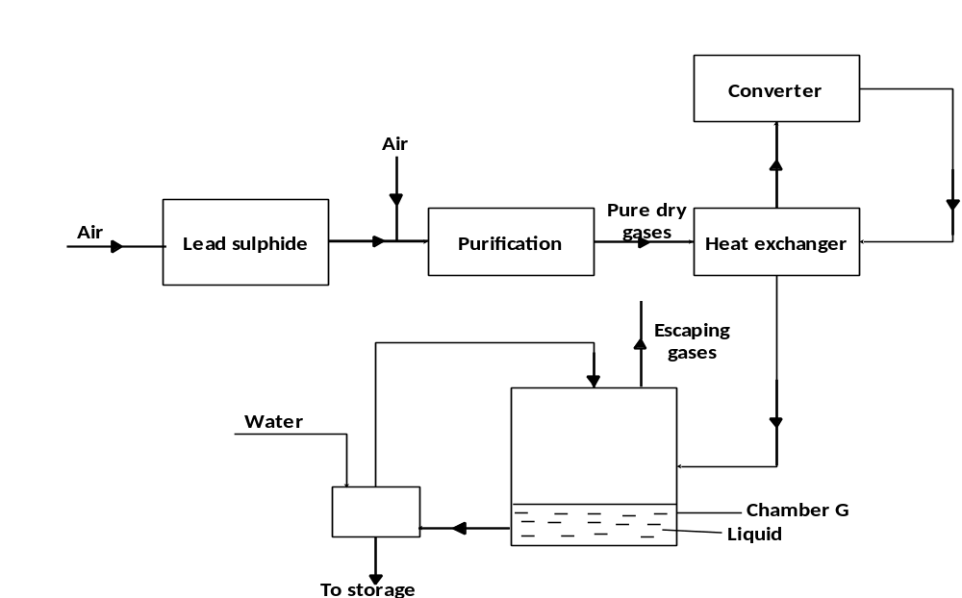

- Write the equation for the reaction in which sulphur dioxide gas is produced. (1 mark)

- Why is it necessary to keep the gases pure and dry? (1 mark)

- Describe the process that takes place in chamber G. (1 mark)

- Name the gases that escape into the environment. (1 mark)

- State and explain the harmful effect on the environment of one of the gases named in (iv) above (1 mark)

- Give one reason why it is necessary to use a pressure of 2-3 atmospheres and not more. (1 mark)

(b) (i) Complete the table below to show the observations made when concentrated sulphuric (VI) acid is
added to the substances shown. (2 marks)

Substance | Observation
Iron fillings
Crystals of white sugar
(ii) Give reasons for the observations made using:
- iron fillings (1 mark)

- Crystals of white sugar. (1 mark)

- (a) The set-up below was used to prepare dry hydrogen chloride gas, and investigate its effect on heated iron filings.
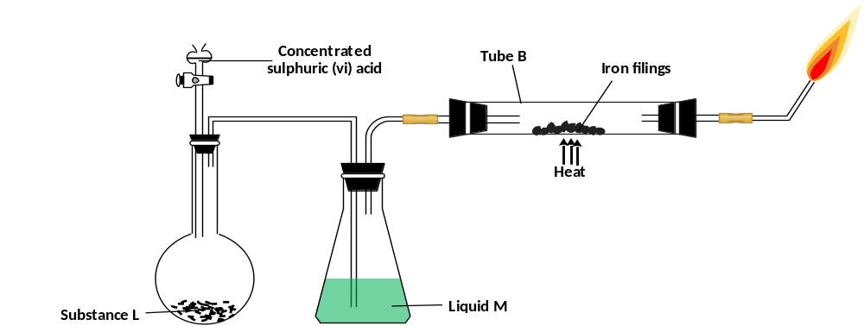

- Name substance L (1 mark)

- Name liquid M. (1 mark)

- What will be observed in tube B? (1 mark)

- Write an equation for the reaction that occurs in tube B. (1 mark)

- Why is the gas from tube B burnt? (1 mark)

(b) (i) Explain the following observations:
(I) A white precipitate is formed when hydrogen chloride gas is pass through aqueous silver nitrate. (1 mark)

(II) Hydrogen chloride gas fumes in ammonia gas. (1 mark)

(ii) State two uses of hydrogen chloride gas. (1 mark)

(c) The diagram below is a representation of an industrial process for the manufacture of a bleaching
powder.

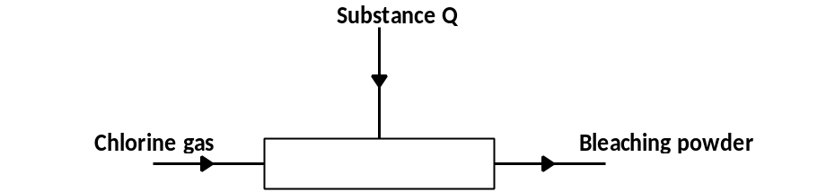

- Name substance Q. (1 mark)

- When the bleaching powder is added to water during washing, a lot of soap is used. Explain. (1mark)

- The flow charts below show an analysis of a mixture R that contains two salts. Study the analysis and answer the questions that follow.

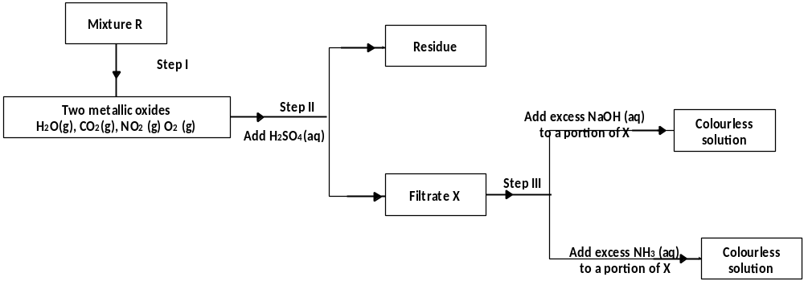

(a) (i) What condition is necessary for the process in step I to take place? (1 mark)

- Write ionic equation for the reaction between the cation in filtrate X and aqueous ammonia. (1 mark)

(iii) What observation would indicate the presence of NO_{2 (g)} in step I? (2 marks)

(iv) State how water vapour, in step I could be identified. (1 mark)

(b)
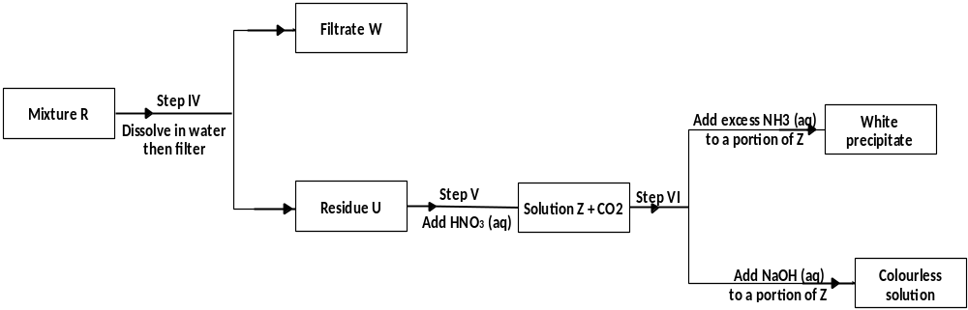

- What conclusion can be drawn from step IV only? Explain? (2 marks)

- Write the formula of an anion present in the residue U. Explain (2 marks)

- Suggest the identity of the cation present in solution Z. (1 mark)

(c) Name the two salts present in the mixture R. (2 marks)

- In order to determine the molar of neutralization of sodium hydroxide, 100cm³ of 1M sodium hydroxide and 100cm³ of 1 M hydrochloric acid both at the same initial temperature were mixed and stirred continuously with a thermometer. The thermometer of the resulting solution was recorded after every 30 seconds until the highest temperature of the solution was attained. Thereafter the temperature of the solution was recorded for a further two minutes
- (i) Why was it necessary to stir the mixture of the two solutions? (1 mark)

(ii) Write an ionic equation for the reaction which took place. (1 mark)

- The sketch below was obtained when the temperature of the mixture were plotted against time. Study
and answer the questions that follow.

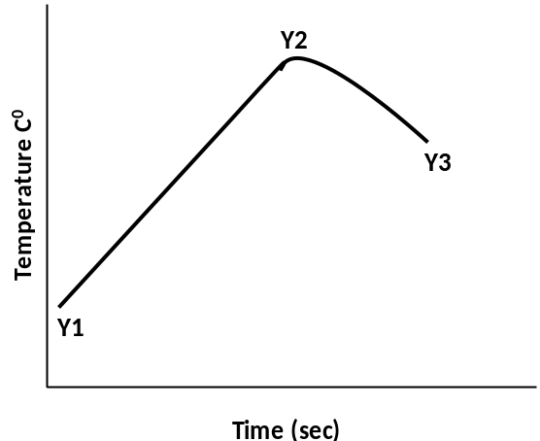

- What is the significance of point Y2? (1 mark)

- Explain why there is a temperature change between points.
Y1 and Y2 (1 mark)

Y3 and Y4 (1 mark)

- In the initial temperature for both solutions was 24.5⁰C and the highest temperature attained by the
mixture was 30.9⁰C. Calculate the:
- Heat change for the reaction (2 marks)
(specific heat capacity of the solution = 4.2Jg ⁻¹K⁻¹ and the density of the solution = 1.0g/cm³

- Molar heat of neutralization of sodium hydroxide. (2 marks)

- Explain how the value of the molar heat of neutralization obtained in this experiment would compare
with the one that would be obtained if the experiment was repeated using 100cm³ of 1 Methanoic acid instead of hydrochloric acid. (2 marks)

- On the grid provided below, draw an energy level diagram for the reaction between hydrochloric acid
And sodium hydroxide

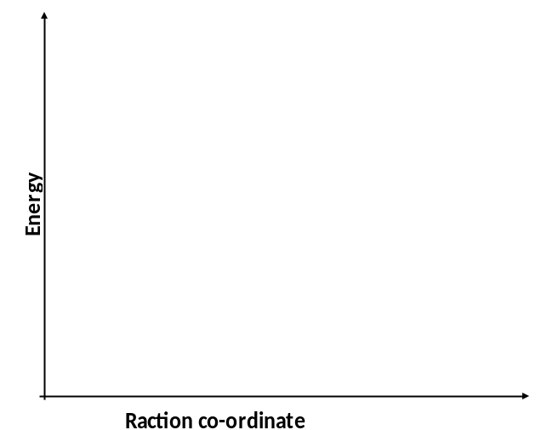

- (a) Study the table below and answer the questions that follow

Compound | Melting point (˚C) | Boiling point (˚C)
CH₂O₂  C₂H₄  C₂H₄O₂  C₃H₈O  C₂H₆ | 8.4  -169  16.6  -126  -183 | 101  -104  118  97  -89

- Which of the compounds is a solid at 15 ˚c? Explain (1 mark)

- Name and draw the structural formula of CH₂O₂ (1 mark)

- Describe one chemical test that can be used to distinguish C₃H₈O with C₂H₄O₂ (1 mark)

- Choose two compounds which are members of the same homologous series and explain the difference in their melting points (2 marks)

- Choose a compound which decolorizes bromine instantly (1 mark)

- Write an equation for the reaction between C₂H₆ and one mole of chlorine
(1 mark)

- How does the solubility of C₃H₈O (not an ether) differ from the solubility of C₂H₆ in water? Explain (2 mark)

b) i) What is an isomer? (1Mark)

ii) Name one isomer of dimethyl ether (C H₃OCH₃) (1 mark)

- Draw and name the structure of the polymer obtained by polymerization of the substance.
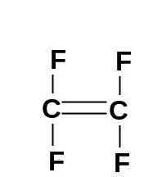
(1 mark)

